**JAVA FOUNDATION TRAINING**

**BATCH 8**

**Name:** Rajalakshmi Ganesh             **Case Study:** TicketBookingSystem

**Tasks 3: Aggregate functions, Having, Order By, GroupBy and Joins:**

**1. Write a SQL query to List Events and Their Average Ticket Prices.**

**🡪** SELECT event_id, event_name, AVG (ticket_price) AS average_price

FROM event

GROUP BY event_id;

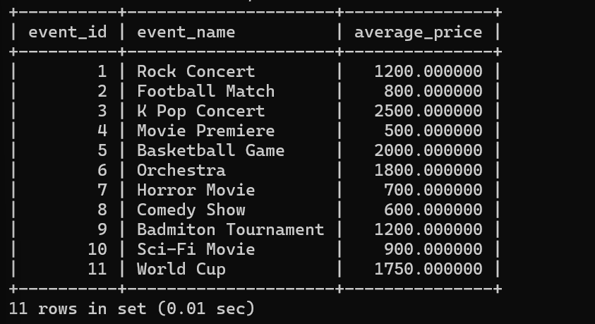

**2. Write a SQL query to Calculate the Total Revenue Generated by Events.**

**🡪** SELECT e.event_id, e.event_name, SUM (b.total_cost) AS total_revenue

FROM event e, booking b WHERE e.event_id=b.event_id

GROUP BY e.event_id;

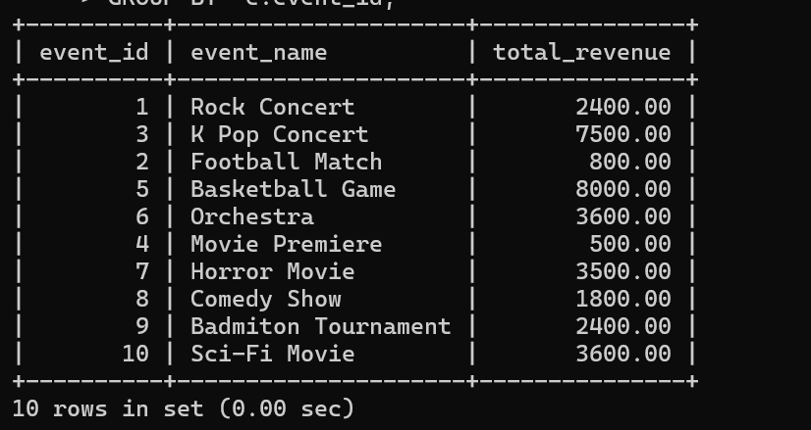

**3. Write a SQL query to find the event with the highest ticket sales.**

**🡪** SELECT e.event_id, e.event_name, SUM(b.num_tickets) AS ticket_sale

FROM booking b , event e

WHERE b.event_id = e.event_id

GROUP BY e.event_id, e.event_name

ORDER BY ticket_sale DESC

LIMIT 1;

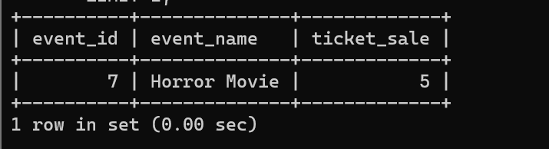

**4. Write a SQL query to Calculate the Total Number of Tickets Sold for Each Event.**

**🡪** SELECT e.event_id, e.event_name, SUM(b.num_tickets) AS tickets_sold

FROM event e, booking b

WHERE e.event_id=b.event_id

GROUP BY event_id,event_name;

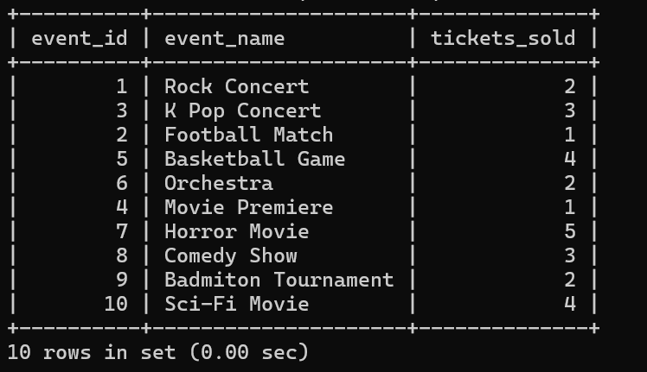

**5. Write a SQL query to Find Events with No Ticket Sales.**

**🡪** SELECT e.event_id,e.event_name, SUM(b.num_tickets) AS ticket_sold

FROM event e,booking b

WHERE e.event_id=b.event_id

GROUP BY event_id,event_name

HAVING ticket_sold =0;

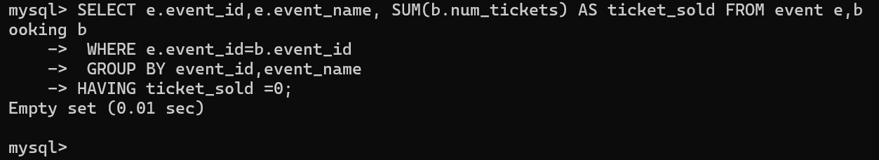

**6. Write a SQL query to Find the User Who Has Booked the Most Tickets.**

**🡪** SELECT c.customer_id,

c.customer_name,e.event_id,e.event_name,

SUM(b.num_tickets) AS ticket_sale

FROM customer c,booking b,event e

WHERE c.customer_id=b.customer_id

GROUP BY c.customer_id,e.event_id  
ORDER BY ticket_sale DESC

LIMIT 1;

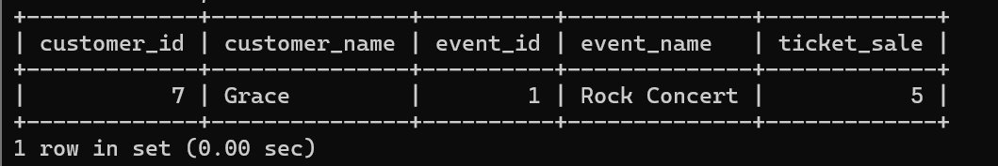

**7. Write a SQL query to List Events and the total number of tickets sold for each month.**

**🡪** SELECT e.event_id,e.event_name, MONTH(e.event_date)

AS month,SUM(b.num_tickets) AS ticket_sale

FROM event e,booking b

WHERE e.event_id=b.event_id

GROUP BY e.event_id

ORDER BY month;

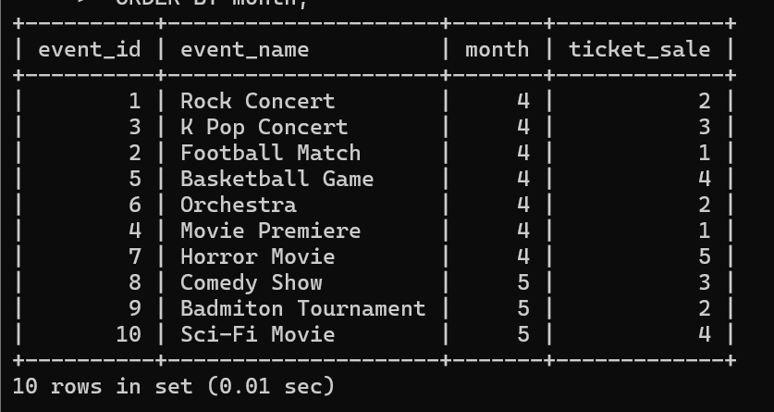

**8. Write a SQL query to calculate the average Ticket Price for Events in Each Venue.**

🡪 SELECT v.venue_id,v.venue_name, AVG(e.ticket_price) AS avg_price

FROM event e,venue v

WHERE e.venue_id=v.venue_id  
 GROUP BY v.venue_id;

**Using JOINS:**

🡪 SELECT v.venue_id, v.venue_name, AVG(e.ticket_price) AS avg_price

FROM event e

JOIN venue v ON e.venue_id = v.venue_id

GROUP BY v.venue_id,

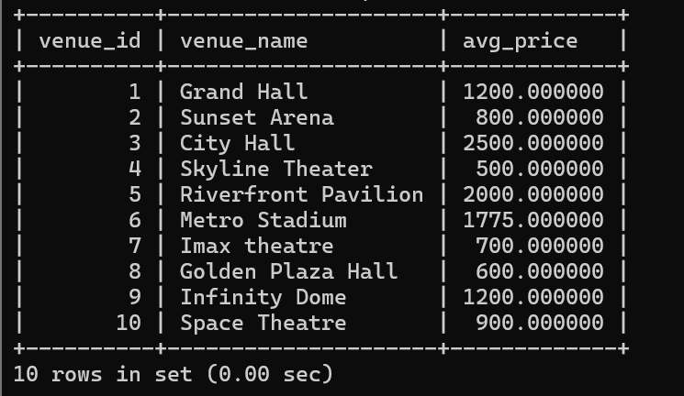

**9. Write a SQL query to calculate the total Number of Tickets Sold for Each Event Type.**

**🡪** SELECT e.event_type,SUM(b.num_tickets) AS

total_tickets_sold

FROM event e,booking b

WHERE e.event_id=b.event_id

GROUP BY e.event_type;

**Using JOINS:**

**🡪** SELECT e.event_type, SUM(b.num_tickets) AS

total_tickets_sold

FROM booking b

JOIN event e ON b.event_id=e.event_id

GROUP BY e.event_type;

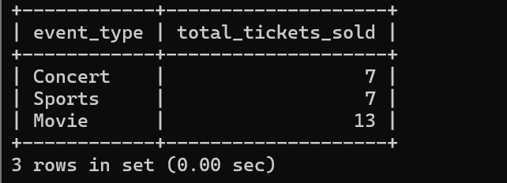

**10. Write a SQL query to calculate the total Revenue Generated by Events in Each Year.**

**🡪** SELECT e.event_id,e.event_name,YEAR(e.event_date) AS

year, SUM(b.total_cost)

FROM event e,booking b

WHERE e.event_id=b.event_id

GROUP BY e.event_id

ORDER BY year;

**Using JOINS:**

**🡪** SELECT e.event_id,e.event_name,YEAR(e.event_date) AS

year, SUM(b.total_cost)

FROM event e

JOIN booking b ON b.event_id=e.event_id

GROUP BY e.event_id

ORDER BY year;

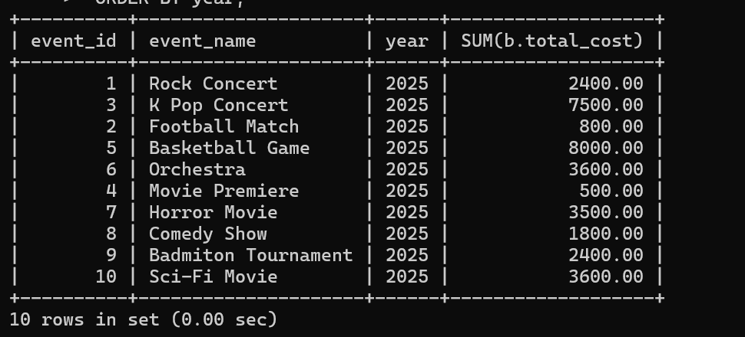

**11. Write a SQL query to list users who have booked tickets for multiple events.**

**🡪** SELECT c.customer_id,c.customer_name,

COUNT(DISTINCT b.event_id) AS total_event_count

FROM customer c,booking b

WHERE c.customer_id=b.customer_id

GROUP BY c.customer_id

HAVING total_event_count>1;

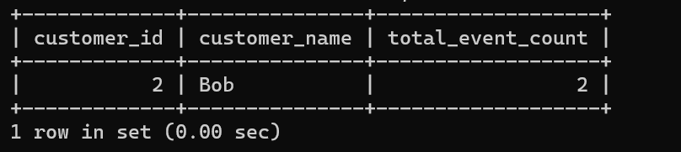

**Using JOINS:**

**🡪** SELECT c.customer_id, c.customer_name, COUNT(DISTINCT b.event_id) AS total_event_count

FROM booking b

JOIN customer c ON b.customer_id = c.customer_id

GROUP BY c.customer_id, c.customer_name

HAVING total_event_count > 1;

**12. Write a SQL query to calculate the Total Revenue Generated by Events for Each User.**

**🡪** SELECT c.customer_id,c.customer_name,

SUM(b.total_cost) AS total_revenue

FROM customer c,booking b

WHERE c.customer_id=b.customer_id

GROUP BY c.customer_id;

**Using JOINS:**

**🡪** SELECT c.customer_id, c.customer_name, SUM(b.total_cost) AS total_revenue

FROM booking b

JOIN customer c ON b.customer_id = c.customer_id

GROUP BY c.customer_id, c.customer_name;

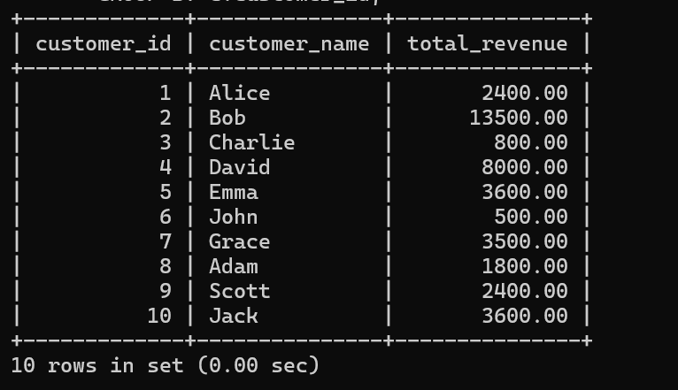

**13. Write a SQL query to calculate the Average Ticket Price for Events in Each Category and Venue.**

**🡪** SELECT e.event_type,v.venue_name,AVG(e.ticket_price) as

avg_ticket_price

FROM event e,venue v

WHERE e.venue_id=v.venue_id

GROUP BY e.event_type,v.venue_name;

**Using JOINS:**

🡪 SELECT e.event_type, v.venue_name, AVG(e.ticket_price) AS avg_ticket_price

FROM event e

JOIN venue v ON e.venue_id = v.venue_id

GROUP BY e.event_type, v.venue_name;

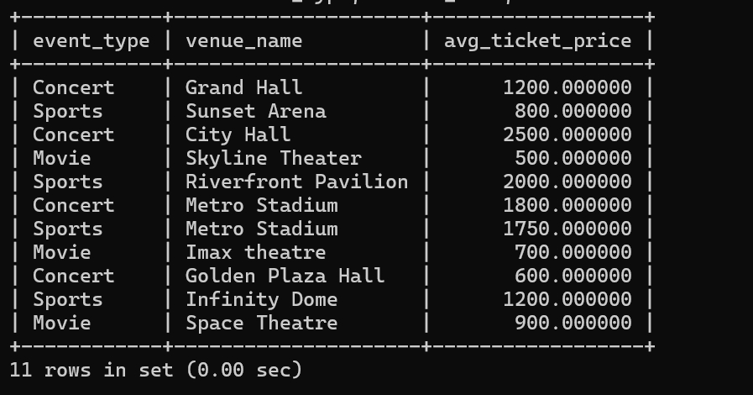

**14. Write a SQL query to list Users and the Total Number of Tickets They've Purchased in the Last 30 Days.**

**🡪** SELECT c.customer_id, c.customer_name, SUM(b.num_tickets) as total_tickets

FROM customer c,booking b  
WHERE c.customer_id=b.customer_id AND

DATEDIFF(CURDATE(),b.booking_date)<=30  
GROUP BY c.customer_id;

**Using JOINS:**

**🡪** SELECT c.customer_id, c.customer_name, SUM(b.num_tickets) AS total_tickets

FROM booking b

JOIN customer c ON b.customer_id = c.customer_id

WHERE DATEDIFF(CURDATE(), b.booking_date) <= 30

GROUP BY c.customer_id, c.customer_name;

